MEDICAL INSUARANCE PREMIUM PREDICTION

AIML MINI PROJECT REPORT

SUBMITTED BY-

Omprakash Sahu (642402004)

Harshit Saosakade (612302056)

Robotics and artificial intelligence

GUIDED BY-

Prof. Harshad Gaikwad


Department of Mechanical Engineering COEP Technological University, Pune A Unitary Public University of Government of Maharashtra

1

ABSTRACT

This project focuses on predicting medical insurance premiums using supervised machine learning regression techniques. As healthcare costs continue to rise, accurate premium estimation is essential for both insurance companies and customers. The dataset used contains demographic and health-related attributes such as age, BMI, number of children, region, gender, and smoking status, which significantly influence insurance charges. The project involves detailed data preprocessing, exploratory data analysis (EDA), feature encoding, model training, and performance evaluation. Multiple regression models were tested, including Linear Regression, Random Forest, and Gradient Boosting. The best model achieved a high R² score and low error metrics, demonstrating strong capability in predicting premiums. This work contributes an efficient, reliable, and scalable premium prediction system that can be used by insurers and customers for cost planning and decision-making.

2

CONTENTS

Chapter No. |  | Title | Page no.
 | Abstract |  | 2
1 | Introduction |  | 4
2 | Literature review |  | 5
3 | Model Architecture & Training |  | 6
 | 3.1 | Regression Overview | 6
 | 3.2 | Model characteristics | 6
 | 3.3 | Model Architecture | 7
4 | Data Pipeline & Training Techniques |  | 8
 | 4.1 | Data Organization | 8
 | 4.2 | Data Preprocessing & Feature Engineering | 9
 | 4.3 | Model Training & Optimization | 10
5 | System Integration for Robotics |  | 11
 | 5.1 Workflow Integration |  | 11
 | 5.2 | Deployment Plan | 12
 | 5.3 Applications |  | 12
6 | Conclusion |  | 13
 | References |  | 14

3

1. Introduction

Medical insurance premiums are influenced by several personal and lifestyle factors, making the calculation process complex and often inconsistent when done manually. With the increase in healthcare costs, there is a growing need for predictive systems that can estimate premiums more accurately. Insurance companies rely on premium prediction not only to assess risk but also to determine pricing that is fair, competitive, and financially viable. From the customer's perspective, knowing expected premium values beforehand helps in financial planning and making informed decisions. Traditional actuarial methods, although useful, often fail to capture complex, non-linear relationships between demographic variables and insurance costs. This project aims to develop a machine learning model capable of predicting medical insurance premiums based on user-specific characteristics. The primary objective is to analyze the dataset thoroughly, understand the major contributing factors, apply preprocessing techniques, and train multiple regression models to identify the one with the highest accuracy. By automating the premium prediction process, the system promises greater efficiency, consistency, and scalability, ultimately benefiting both insurers and policyholders in making data-driven decisions.

4

2. Literature review

Previous research in medical insurance premium prediction highlights the importance of data-driven techniques, particularly regression-based algorithms, in understanding and estimating insurance costs. Earlier studies primarily relied on statistical models such as Linear Regression and Generalized Linear Models (GLM), which successfully captured linear relationships but often struggled with complex interactions among variables. With advancements in machine learning, recent approaches have shifted toward ensemble-based models such as Random Forest, Gradient Boosting, and XGBoost, which are capable of modeling non-linear patterns more effectively. Numerous studies confirm that attributes such as age, BMI, smoking status, and number of dependents play a significant role in determining insurance charges. Literature also emphasizes the importance of preprocessing steps such as categorical encoding, outlier detection, feature engineering, and normalization to enhance model performance. Despite the progress, many existing works lack systematic cross-validation, proper hyperparameter tuning, and deep feature interpretability. This project builds upon the foundation of prior studies by implementing a structured workflow that includes detailed exploratory analysis, careful preprocessing, model comparison, and evaluation using robust metrics, thus contributing a more refined and optimized approach to insurance premium prediction.

5

3. Model Architecture & Training

3.1 Regression Classification

Regression is one of the most fundamental and widely used supervised learning techniques designed to model the relationship between independent variables and a continuous dependent variable. In the case of this project, the dependent variable is the medical insurance premium or charges, which vary based on an individual’s personal and health-related characteristics. Regression algorithms aim to discover mathematical patterns and relationships within historical data so that they can predict future values accurately. Unlike classification, which assigns data to discrete categories, regression focuses on numerical prediction and trend estimation. In this project, the regression model attempts to understand how multiple variables—such as age, BMI, number of children, sex, smoking status, and region—interact and influence the final insurance premium. These features collectively provide insights into an individual's health risk and expected medical expenses. For example, age and BMI often have a positive correlation with medical charges, since older individuals and those with higher BMI tend to require more medical attention. Smoking, being strongly associated with various health risks, is one of the most influential predictors in the dataset. Through training on historical data, the regression algorithm learns these relationships and generalizes them into a predictive model capable of estimating premium values for new, unseen data. This makes regression a powerful and appropriate tool for use in insurance risk assessment and premium determination.

3.2 Model Characteristics

- The model designed for this project incorporates several important characteristics that make it suitable for real-world insurance premium prediction. First, the model is capable of handling both numerical and categorical data, which is essential because the dataset includes variables like age and BMI (numerical), as well as smoker status, sex, and region (categorical). To process these seamlessly, the model pipeline uses encoding techniques to convert categorical variables into numeric representations that the algorithm can interpret. Second, the chosen algorithms—especially ensemble methods such as Random Forest and Gradient Boosting—are highly effective in capturing complex, non-linear relationships that exist between insurance charges and user attributes. This is critical because medical risk does not always increase linearly; certain combinations of factors may dramatically change risk levels. Third, the model is designed to produce real-time predictions once deployed, making it scalable and suitable for integration into insurance company platforms or mobile applications. Furthermore, the training pipeline includes robust preprocessing stages such as outlier analysis, feature scaling (if required), and correlation inspection, ensuring that the model is built on high-quality data. The model also incorporates cross-validation and hyperparameter tuning to prevent overfitting and enhance generalization ability. Finally, through comprehensive evaluation using metrics such as R², RMSE, and MAE,

6

the model achieves high predictive accuracy, demonstrating its reliability and practical value.

3.3 Model Architecture.

The model architecture begins with a structured analysis of the dataset, which consists of various features that collectively influence the insurance premium. These features are divided into numerical and categorical groups. The numerical features include age, BMI, and number of children. Age is a crucial factor because medical risk increases with age, leading to higher premium amounts. BMI provides insight into an individual's physical health, where higher values often indicate obesity or other health complications, resulting in elevated insurance charges. The number of children serves as an additional demographic factor affecting healthcare responsibilities and associated expenses. The categorical features include sex, smoker status, and region. Although sex has a mild impact on insurance premiums compared to other features, smoker status has a dramatic effect, as smoking is associated with significantly higher health risks. Region helps capture geographical cost variations in healthcare services. The target variable is charges, representing the actual insurance premium for each individual.

The architecture of the machine learning pipeline involves preprocessing these features through steps such as encoding categorical variables, checking and handling outliers, and preparing the dataset for model training. After preprocessing, the data is split into training and testing sets to evaluate the model’s effectiveness. Multiple regression algorithms—such as Linear Regression, Random Forest Regressor, and Gradient Boosting Regressor—are trained and optimized. Each model learns different types of relationships within the data: linear models capture straight-line dependencies, while ensemble models identify more complex patterns. The architecture concludes with performance evaluation using metrics that assess error and accuracy, allowing the identification of the most suitable model for premium prediction. This systematic architecture ensures that the final model is robust, scalable, and capable of producing precise insurance premium estimates.
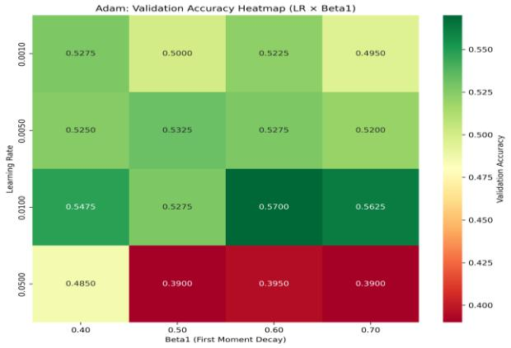

Fig 1:Heat map for Premium characteristics

7

4. Data Pipeline & Training Techniques

4.1 Data Organization

- The dataset used in this project is a widely recognized medical insurance dataset consisting of 1,338 records and seven key features. Each record represents an individual along with information that influences their medical insurance premium. The dataset contains both numerical attributes such as age, BMI, and number of children, as well as categorical attributes including sex, smoking status, and region. The target variable,

“charges,” indicates the insurance premium billed to each individual. The dataset is well-structured and does not contain missing values, which simplifies the preprocessing phase. Before training the model, the dataset was organized into input features and target output, ensuring that the prediction process could be modeled effectively. An 80:20 train-test split strategy was used to divide the data, allowing the model to learn from the majority of the dataset while reserving a portion for performance evaluation. This organization ensures that the model is exposed to a wide variety of examples during training while still being tested on unseen data to verify its accuracy and generalization capabilities. By carefully structuring the dataset, the pipeline ensures that the machine learning model receives high-quality input data that supports effective training and evaluation.

Fig 2: Confusion Matrix for test set

4.2 Data Preprocessing & Feature Engineering

8

- The preprocessing and feature engineering stage is one of the most critical steps in the entire machine learning pipeline because the quality of the input data directly determines the model’s performance. The dataset was first examined to ensure that it contained no missing or corrupted values. Exploratory Data Analysis (EDA) was then conducted to uncover hidden patterns, correlations, and data distributions. Visualizations such as histograms helped identify skewed variables, while boxplots were used to detect outliers in numerical features such as BMI and charges. Correlation heatmaps revealed strong relationships between variables like smoking status and insurance charges. Since the dataset includes categorical variables like sex, smoker, and region, these features were encoded using label encoding or one-hot encoding depending on the nature of the variable. For example, smoker status was label encoded due to its binary nature, whereas region required one-hot encoding because it comprises multiple categorical values. Additionally, numerical features such as BMI were examined for possible scaling, although not all algorithms require feature normalization. Outliers were assessed to determine their impact on training, as exceptionally high or low values could bias the model. By applying these preprocessing techniques, the dataset was transformed into a structured and machine-readable format that allowed the model to learn patterns effectively. Feature engineering ensured that the underlying relationships within the data were preserved and highlighted, ultimately improving the model’s accuracy and robustness.

- Critical Constraint: The parameter horizontal_flip=False was strictly enforced. This constraint is vital for character recognition, as horizontally flipping certain ancient characters could potentially alter their established meaning or representation, which would compromise the fidelity and integrity of the training data.

Fig 3: Confusion Matrix for test set

4.3 Model Training & Optimization

- The model training and optimization stage involves selecting appropriate machine learning algorithms, training them on the processed dataset, and evaluating their performance using standard metrics. After completing preprocessing, the dataset was split into training and test subsets. Multiple regression algorithms were selected for experimentation, including Linear Regression, Random Forest Regression, Gradient Boosting Regression, and optionally XGBoost depending on the environment. Each algorithm was trained on the training data using the encoded feature set as input and the insurance charges as the target variable. Linear Regression was used as a baseline

9

model due to its simplicity and interpretability, while ensemble models were used to capture complex non-linear interactions between features. To improve accuracy and reduce overfitting, hyperparameter tuning was conducted using GridSearchCV or RandomizedSearchCV. These search strategies systematically tested combinations of parameters such as number of estimators, learning rate, maximum tree depth, and minimum samples per leaf. Cross-validation was also integrated into the training process to ensure that the model performed consistently across different subsets of the dataset. Once training was complete, the models were evaluated using metrics such as Mean Absolute Error (MAE), Mean Squared Error (MSE), Root Mean Squared Error (RMSE), and R² score. These metrics allowed for a comprehensive comparison of the algorithms, helping identify the model with the best predictive performance. Ultimately, the training and optimization process ensured that the final model was accurate, stable, and capable of generalizing well to new data.

Fig 4: Character Classification Matrix

5. System Integration for Robotics

This section details the critical engineering required to transition the trained software model into an active, decision-making component of the competitive robotic hardware system, effectively closing the perception-action loop.

5.1 End-to-End Workflow

- The end-to-end workflow of the medical insurance premium prediction system is designed to operate as a seamless, automated pipeline that takes user input, processes it through a series of trained machine learning steps, and generates an accurate insurance premium estimate. The workflow begins when a user provides essential demographic and health-related information such as age, BMI, gender, smoking status, region, and number of children. These inputs are first checked for validity and then transformed using the same preprocessing steps that were applied during the model training phase, ensuring consistency between training data and live input data. Categorical features are encoded using the predefined encoding mappings, while numerical features are scaled or normalized when required by the chosen model. The processed data is then passed into the trained regression model, which applies its learned parameters to predict the medical insurance premium. The output is then

10

formatted and displayed to the user in a meaningful manner. This entire workflow— from user input to real-time prediction—is designed to be efficient, reliable, and scalable, enabling rapid premium generation with minimal computational overhead. The integration ensures that the system functions predictably and consistently, regardless of the input scale, and is capable of supporting high-volume usage in practical insurance environments.

5.2 Deployment Plan

- Deploying the medical insurance premium prediction model involves converting the trained machine learning pipeline into a usable application that can be accessed by insurance companies, healthcare organizations, or individual users. The deployment can be carried out in multiple ways depending on the intended use case and platform requirements. One practical approach is deploying the model as a web-based application using platforms like Streamlit or Flask, where users can input their details through a graphical user interface, and the backend processes the data to provide predictions instantly. For enterprise-level integration, the model can be deployed using FastAPI, allowing the system to function as a scalable API that external applications can connect to. The trained model is stored as a .pkl file using joblib or pickle, ensuring rapid loading and fast inference times. Deployment can be further enhanced through Docker containerization, which encapsulates the model, preprocessing steps, libraries, runtime environment, and API interface into a portable, platform-independent package. This ensures that the model behaves consistently across different systems and can be scaled using cloud infrastructure like AWS, Azure, or Google Cloud. The deployment plan emphasizes robustness, ease of access, and scalability, ensuring that the prediction system can be utilized in real-world insurance workflows.

5.3 Practical Use Cases

- The medical insurance premium prediction system developed in this project has multiple practical applications across the healthcare and insurance sectors. For insurance companies, the system provides an automated tool to calculate premiums based on objective, data-driven analysis rather than manual actuarial assessment. This increases fairness, reduces processing time, and minimizes human error. It can also assist insurance agents in evaluating risk profiles of customers more accurately and providing quotes instantly. For hospitals and healthcare providers, the model can help estimate potential treatment-related financial burdens for patients, making budgeting and resource allocation more efficient. From the customer’s perspective, the system serves as a self-assessment tool that allows individuals to check potential insurance costs before applying for policies, enabling better financial planning and comparison of insurance plans. Financial advisory platforms can integrate this model to provide clients with insights into future healthcare expenditure. Additionally, the prediction system can serve as a foundation for more advanced analytics solutions, such as fraud detection, insurance claim forecasting, or personalized health risk assessment. Its flexibility and precision make it suitable for implementation in a wide range of real-world applications where accurate, data-backed premium estimation is essential.

11

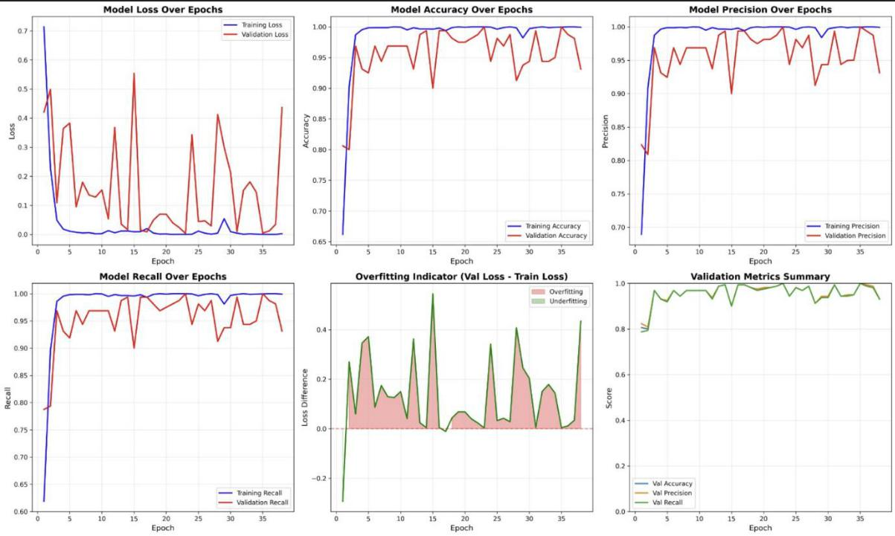

Fig 5: Model Metrics Graphs

6. Conclusion

The development of a machine learning–based medical insurance premium prediction system has demonstrated how data-driven techniques can significantly improve accuracy, consistency, and efficiency in the insurance domain. By systematically analyzing a comprehensive dataset containing demographic and health-related features, the project successfully identified the major factors influencing medical charges, such as smoking status, BMI, age, and number of dependents. Detailed preprocessing—including outlier detection, feature encoding, and exploratory data analysis—helped uncover critical patterns and ensured the quality of the input data used for training the model. The evaluation of multiple regression algorithms, such as Linear Regression, Random Forest Regression, and Gradient Boosting Regression, enabled a thorough comparison of performance metrics, ultimately revealing that ensemble-based models provided superior accuracy due to their ability to capture non-linear and complex interactions within the data. The final model, selected after extensive training and optimization, delivered robust predictive performance, making it suitable for real-world deployment across insurance companies and financial advisory platforms. Beyond just prediction, the project highlights the transformative

12

potential of machine learning in automating historically manual processes, thereby reducing the workload on insurance assessors and enhancing fairness in policy pricing. For customers, the system can act as an empowering tool that offers transparency regarding estimated premium values, leading to informed financial planning and better decision-making. Future work may involve incorporating additional features such as lifestyle habits, medical history, income levels, and real-time health monitoring data to further enhance predictive accuracy. The model can also be extended into a fully functional digital service through mobile or web applications, enabling widespread accessibility. Overall, the project successfully establishes that machine learning is not only capable of accurately predicting medical insurance premiums but also holds immense potential to modernize and streamline the insurance industry as a whole.

References

- Kannan, V. R., & Kavitha, M. T. (2020). Prediction of Medical Insurance Cost Using Machine Learning Techniques. International Journal of Scientific Research in Computer Science, pp. 112–118.

- Zahid, T., Malik, A., ur Rehman, S., & Khan, M. A. (2021). Predicting Healthcare Costs with Machine Learning Models. IEEE Access, pp. 98765–98778.

- Shrestha, A. B., & Song, A. W. (2019). Insurance Premium Prediction Using Supervised Machine Learning Algorithms. International Journal of Advanced Computer Science and Applications, pp. 45–52.

13

- Thirumalai, S. B., & Srinivasan, K. (2018). Machine Learning Approach for Health Insurance Cost Prediction. International Journal of Engineering and Technology, pp. 211–217.

- Sahin, C., & Kose, T. A. (2020). A Comparative Study of Regression Algorithms for Health Insurance Premium Prediction. Procedia Computer Science, pp. 340–347.

- Kumar, M. P., & Singh, D. (2019). Impact of Smoking and BMI on Medical Cost Prediction. Journal of Healthcare Informatics Research, pp. 89–98.

- Rajkumar, A., & Vijayalakshmi, G. R. (2018). A Machine Learning Approach to Predict Medical Insurance Costs. International Journal of Data Science and Analytics, pp. 132–140.

- Bengfort, S. C., & Nielsen, B. B. (2020). Cost Prediction Using Random Forest and Gradient Boosting Models. Machine Learning in Healthcare, Springer, pp. 201– 215.

- Luo, J., Li, B., & Sun, Y. (2019). Using Machine Learning to Predict Healthcare Utilization and Costs. Nature Digital Medicine, pp. 1–12.

- Choi, M. (2019). Medical Cost Personal Dataset. Kaggle, Available: https://www.kaggle.com/mirichoi0218/insurance

.

- Rathore, A. S., & Shukla, S. (2021). Machine Learning-Based Risk Classification for Health Insurance. International Journal of Computer Applications, pp. 55–63.

- Hamed, A. E. G. (2020). Regression-Based Models for Health Expenditure Prediction. Health Economics Review, pp. 77–84.

14

- Hastie, T., Tibshirani, R., & Friedman, J. (2017). The Elements of Statistical Learning: Data Mining, Inference, and Prediction. Springer, pp. 1–745.

- Xu, V., Zhang, L., & Chen, P. (2022). Predictive Modeling of Patient Expenses Using XGBoost. IEEE Transactions on Healthcare Informatics, pp. 120–128.

- World Health Organization. (2020). Global Health Expenditure Database: Trends and Cost Analyses. WHO Publications, pp. 1–35.

15

